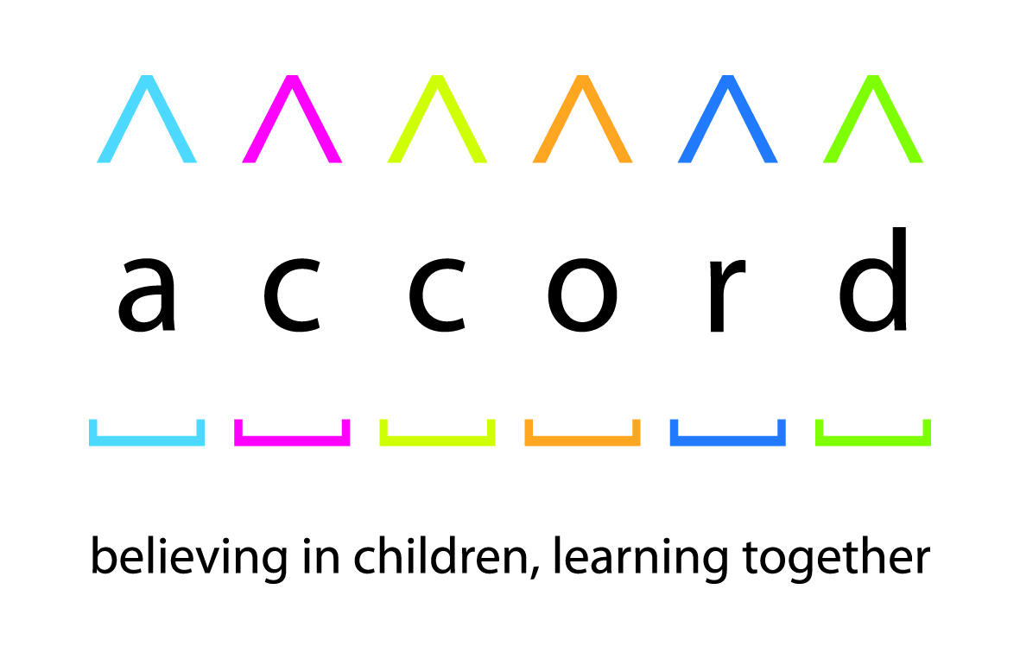bs00719_

**Inclusive SACREs Award nomination form**

**1. Contact details:**

|  |  |
| --- | --- |
| **SACRE name:** |  |
| **Name and position of**  **main contact for the Award:** |  |
| **Main contact's telephone number and email address:** |  |
| **Name and email of SACRE Chair** (if different from above)**:** |  |
| **Name and contact email of RE advisors, clerks or local authority staff/ officers that currently actively support the SACRE:** |  |

**2. SACRE details:**

Please provide the information listed below by either including a relevant hyperlink or indicating that the document is to be attached by email with this completed form.[[1]](#footnote-1)

|  |  |
| --- | --- |
| **Copy of the current syllabus,** **and any accompanying guidance:** |  |
| **Copy of the SACRE constitution, along with any standing orders:** |  |
| **Link to SACRE website** (if exists)**:** |  |
| **Link to last annual report:** |  |

|  |  |
| --- | --- |
| **Please list the current membership of your committees A, B, C and D, or any members who are co-opted or attend regularly as an observer, and indicate for which party, tradition or interest group(s) they each represent. Feel free to also indicate any known vacancies.** | |
| **Committee A:** | |
|  |  |
| **Committee B:** | |
|  |  |
| **Committee C:** | |
|  |  |
| **Committee D:** | |
|  |  |
| **Co-opted:** | |
|  |  |
| **Observers:** | |
|  |  |

**3. SACRE remit and resources:** (no more than 250 words)

Please describe – in no more than 225 words – the characteristics of the area the SACRE covers and the number of schools that are currently required to adhere to its syllabus. This is also an opportunity to describe the access to subject expertise and the level of material support the SACRE receives, including from the local authority.

|  |
| --- |
|  |

**4. Implementation of being an inclusive SACRE:** (no more than 850 words)

This is the most important section. The judges recognise there are many competing expectations and demands placed upon the subject. However they are especially interested in the way that the SACRE have sought to boost inclusion, community cohesion, mutual understanding and mutual respect between those of different religions and non-religious worldviews. Please provide specific examples of how these aims are met. It is also recommended to set out at least one innovative approach that has been particularly important or successful. Judges will be interested to find out how the Agreed Syllabus directly advances these aims, but other areas of the SACRE's work that could prove of interest include:

* building a relationship with local schools that are not required to follow the syllabus and forging partnerships with other agencies (such as local academy chains, multi-academy chains and faith school sponsors, or higher or further education providers)
* urging the local authority to ensure that the membership of the SACRE and Agreed Syllabus Conference is diverse and representative, including of the non-religious
* considering the views of pupils, or developing a Youth SACRE or RE Ambassador programme
* support and guidance to schools on making assemblies and/or provision for SMSC development more inclusive
* creative use of Collective Worship determinations
* the production or commissioning of extra resources for teachers, such as with lesson or curriculum planning (please also submit these in digital copy - they will be treated with confidence and only shared amongst the judging panel)
* organising training for Governors or helping tackle gaps in training and Career Professional Development for teachers
* developing support and research networks
* celebrating successes by pupils and schools
* identifying an area of the SACRE's weakness and acting upon it
* targeted help to individual schools
* ideas and help for schools to advance their legal duties, including the Public Sector Equality Duty[[2]](#footnote-2) and requirement to promote British Values and community cohesion

The Award judges are also interested in the provision of high quality RE more generally, so please consider drawing upon examples that highlight how the SACRE has helped in achieving this. Examples might include:

* new ways of working to alleviate the impact of local authority funding restraints
* sharing ideas and concerns with central government
* ensuring continuity, coherence and sustained learning for pupils moving between primary and secondary phases,
* promoting provision for short course or full RS GCSE and A level

|  |
| --- |
|  |

**5: Evaluation and planning for the future:** (no more than 200 words)

Where has the SACRE's work and implementation of its approach been most successful, and why? What lessons were learned? In what way was the SACRE's approach improved as a result? What are major barriers to further improvement, and how might they be overcome? Have any ideas and recommendations be made for the next Agreed Syllabus Conference?

|  |
| --- |
|  |

**Please return the completed nomination to**[**paul@accordcoalition.org.uk**](mailto:paul@accordcoalition.org.uk)

If you wish to submit further external or supplementary evidence for consideration by the judges, please consider including appropriate web links in this form. If you only have information as a hard copy then please consider scanning and uploading it online.

1. If only a paper copy can be submitted, please post it to the Accord Coalition at Unit A, 39 Moreland Street, London, EC1V 8BB. [↑](#footnote-ref-1)
2. The Public Sector Equality Duty was created by Section 149 of the Equality Act 2010 and came into force in 2011. It requires all public bodies and those carrying out public functions to have due regard when carrying out their activities to helping eliminate discrimination, advance equality of opportunity and foster good relations between different people. [http://www.legislation.gov.uk/ukpga/2010/15/section/149](http://www.legislation.gov.uk/ukpga/2010/15/section/149%20) [↑](#footnote-ref-2)