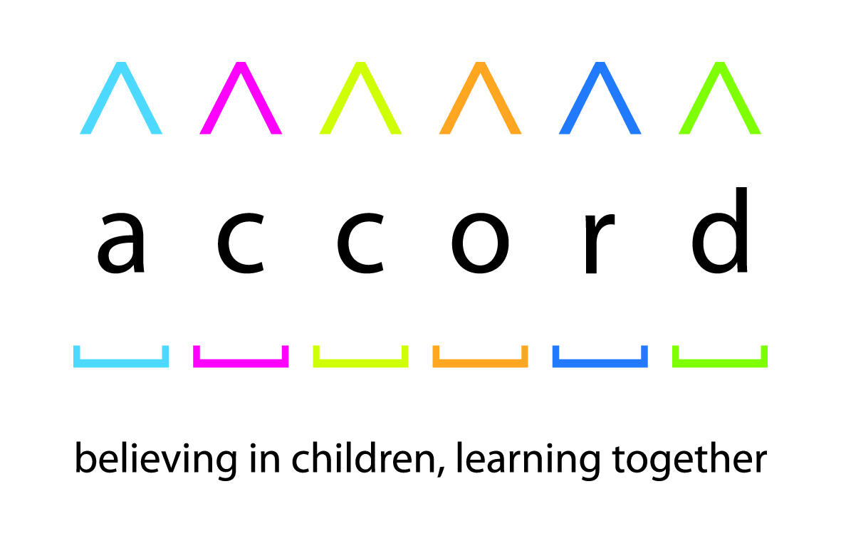bs00719_

|  |  |
| --- | --- |
| **School name:** |  |
| **School address:** |  |
| **School status (e.g. primary, Academy, fee paying) and religious designation (if any):** |  |
| **Age range of school pupils:** |  |
| **Number of pupils on roll:** |  |
| **Name of head teacher:** |  |
| **Name and position of**  **main contact for Accord**  **Award:** |  |
| **Main contact telephone number:** |  |
| **Email address for main contact:** |  |
| **Link to school website:** |  |

**Accord Award 2021: Contact Details**

**Providing supporting information is welcome, but the only information judges will receive from nominees on behalf of schools is that provided in completed nomination forms. If you would like to submit external or supplementary evidence, then please consider including appropriate web links in your form. If you only have information as a hard copy then it could be scanned and uploaded, with an appropriate link then provided**.

**Questions for Applicants**

**Part 1: Context** (no more than 200 words)

Please describe the characteristics of the school population and the local area; the status / denomination (if any) of the school and its relationship with other schools in the area.

|  |
| --- |
|  |

**Part 2: Strategy, ethos and vision for the school** (no more than 300 words)

Please describe ethos of the school, what inspires it and how it informs school strategy.

|  |
| --- |
|  |

**Part 3. Implementation.** (no more than 500 words)

This is the most important section. Please remember that the judges are **especially interested in the way that schools address issues of religion and belief**[[1]](#footnote-1) both inside and outside the school, while it may also be helpful to mention how the school’s inclusive ethos guides its policies on ethnic, cultural and socio-economic differences, as well as gender, age, disability and sexual orientation.

Please give specific examples of how the ethos and strategy are put into practice throughout the school. Examples may include:

* The school’s approach to assemblies and Collective Worship
* Links within and beyond the school community
* Admissions procedures and recruitment / employment policies
* How the curriculum is used to complement the overall ethos and strategy, such as in RE, PSHE or Citizenship
* Events and learning outside the classroom
* Where the school has identified an area of weakness and acted upon it

**And please highlight at least one policy / project that has been especially successful and/or innovative**.

If the school has a religious character, please state the method and extent to which it prioritises pupils by faith in its pupil oversubscription policy and in its recruitment and employment of teachers. If this question is left unanswered judges will assume the school priorities according to its faith or denomination wherever possible.

|  |
| --- |
|  |

**Part 4: Evaluation and planning for the future** (no more than 200 words)

Where have the strategy and implementation been most successful, and why? Where is there room for improvement, and what lessons have been learned?

|  |
| --- |
|  |

**Please return the completed nomination to**[**paul@accordcoalition.org.uk**](mailto:paul@accordcoalition.org.uk)

1. 'Religion and beliefs' means religious and non-religious worldviews. [↑](#footnote-ref-1)